***Address of array***

#include <stdio.h>

int main()

{

int upper[10], find[10],type_DT,size_DT;

int n,base_addr=0,actual_addr=0,i,j,offset=0;

printf("Enter the dimension of array:");

scanf("%d",&n);

for(i=0;i<n;i++)

{

printf("Enter the %d dimension of the upper bound array: ",i);

scanf("%d",&upper[i]);

}

for(i=0;i<n;i++)

{

printf("Enter the %d dimension to find the address of the array:",i);

scanf("%d",&find[i]);

}

printf("Enter the base address of the upper bound array: ");

scanf("%d",&base_addr);

size_DT=4;

for(int i=0;i<n;i++)

{

int temp=find[i];

for(int j=i+1;j<n;j++)

{

temp=temp*upper[j];

}

offset=offset+temp;

}

actual_addr=base_addr+(size_DT*offset);

printf("Actual address: %d",actual_addr);

return 0;

}

Output:

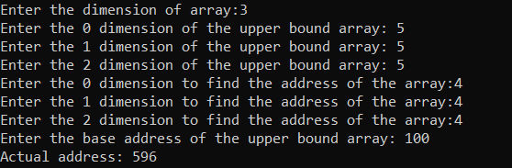

***Arrays with pointers***

#include <stdio.h>

int main(){

int a[10], b[10][10], n, d;

printf("Enter dimention of array (1 or 2): \n");

scanf("%d",&d);

printf("Enter limit of array: \n");

scanf("%d",&n);

int *ptr = a; //*ptr gets address of "a"

int *ptrb = &b[0][0];

// for (int j = 0; j < n; j++) {

// printf("Data in %d = %d\n",ptr+j, *ptr+j); // "ptr" gives the address, adding * gives value

// }

if (d==1){

printf("Enter the elemrnts of the array: \n");

for (int i = 0; i < n; i++) {

printf("Enter a[%d]: ",i);

scanf("%d",&a[i]);

}

for (int *j = a; j < ptr+n; j++) {

printf("Data in %d = %d\n",j, *j); // "ptr" gives the address, adding * gives value

}

}

else if(d==2){

printf("Enter the elements of the array: \n");

for (int q = 0; q < n; q++) {

for (int r = 0; r < n; r++) {

printf("Enter a[%d][%d]: ",q,r);

scanf("%d",&b[q][r]);

}

}

for (int i = 0; i < n; i++) {

for (int j = 0; j < n; j++) {

printf("b[%d][%d]= %d\n",i,j,*(*(b+i)+j));

}

}

}

else{

printf("Invalid input");

}

return 0;

}

Output:

